FTF FY 2023 Performance Scorecard USAID Fredonia

This Feed the Future (FTF) Performance Scorecard assesses the REFS Bureau’s progress toward FY 2030 Performance Targets. There are two steps to calculate annual progress. The first is to calculate the annual values. The second step is to assess OU progress toward the FY 2030 targets.

# Performance Overview



The FY 2023 **On track** value is determined by drawing a line from the baseline (FY 2022) to the FY 2030 Target. For FY 2023, Performance Targets are considered **On track** if they have reported at least 90% of the that value.

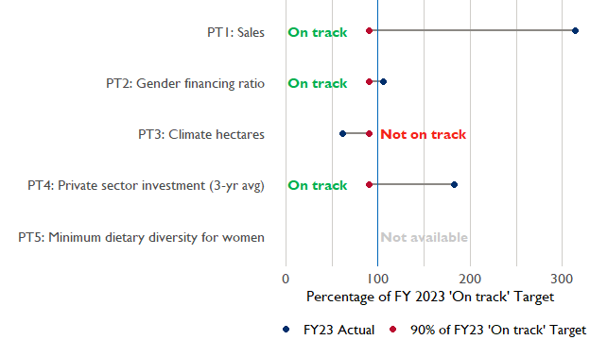

**Note:** *For Performance Target 2 (Gender financing ratio), the target is to increase financing to females for those OUs that are already achieving parity ($1).*

*For Performance Target 4 (PSI), all targets are relative to the last three years’ reporting. In future years, the interim targets may increase.*

*For Performance Target 5 (MDD-W), all FY23 actual values are also the baseline, and may have been collected in a prior year. See the detail page for more information.*

*See detailed* [*methodology document*](https://docs.google.com/document/d/13n-43ppFiGKauscQ7HaAiQDCM4DssGEgRdq2fMyTDn0/edit) *here.*

### Performance Target Details

## Performance Target 1: Value of sales to USG-assisted individuals and firms

In FY23, USAID Fredonia had 9 activities that aligned the ‘Value of annual sales from producers and firms receiving USG assistance’ (EG.3.2-26), and 7 contributed to the sales total of $1,780,800,000.

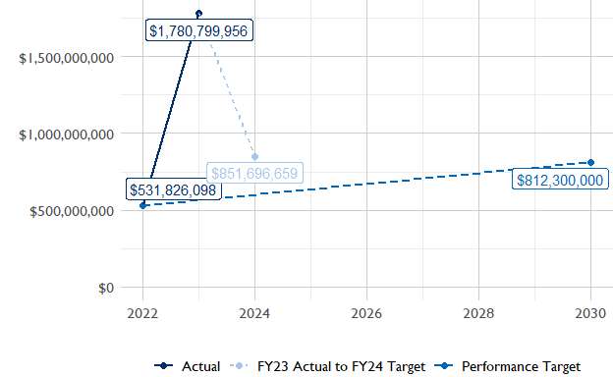

### Performance Target 2: Gender financing ratio



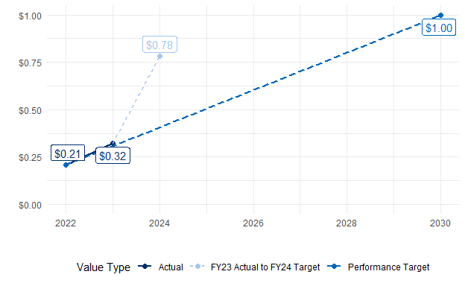

In FY23, USAID Fredonia had 3 IMs/Activities that reported all four sex disaggregates needed to contribute to PT2. The total value of financing among all activities, regardless of disaggregates, was $11,190,000 (EG.3.2-27 total), with $11,190,000 that was disaggregated to males and females, and an additional $0 to firms with both males and females and NA that was not sex disaggregated.

### Performance Target 3: Hectares under climate adaptation and risk management practices



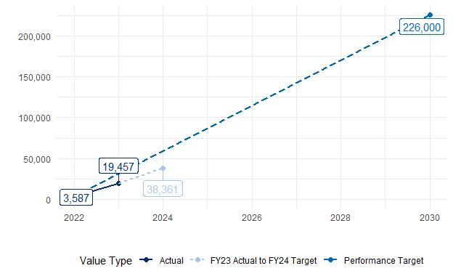

In FY23, USAID Fredonia had 19 activities that aligned the indicator for hectares under improved management practices (EG.3.2-25). Of those activities, 3 reported on the ‘Climate adaptation/climate risk management’ disaggregate and contributed to the OU total for this PT.

### Performance Target 4: Private sector investment leveraged by USG-assisted firms and individuals



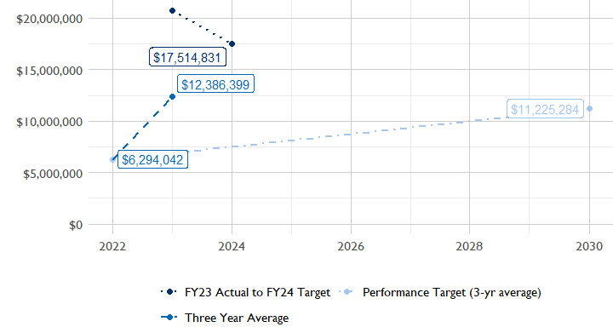

In FY23, USAID Fredonia had 7 activities that aligned the private sector investment indicator (EG.3.1-15/-14), ‘Value of new private sector investment leveraged by the USG to support food security and nutrition’, and 7 contributed to the OU total in FY2023.

### Performance Target 5: Minimum Dietary Diversity for Women



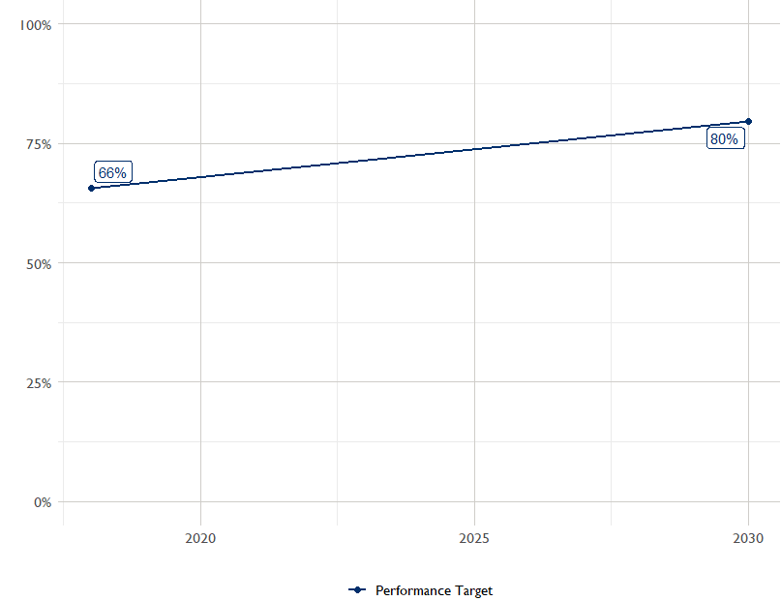

The most recent population-based survey (PBS) in USAID was in 2021 and it showed that 66 percent of women in the lowest income quintile within the ZOI had access to a diet of minimum diversity. The FY30 target is 80 percent. The next PBS is scheduled for 2025 and will show progress toward the target.

## Agricultural Transformation Index Score

REFS/FTF-PAE uses the [IFPRI Agricultural Transformation Index (ATI)](https://agrilinks.org/events/drivers-agrifood-system-transformation-lessons-feed-future-country-studies) Score as a high level indicator of the status of agricultural market systems in each country.

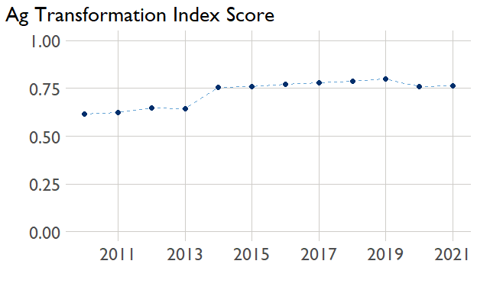

## Budget Trend

At the Operating Unit level, the Performance Targets are based in part on the FY 2023 budget request. For the REFS Bureau, this value was divided by two to account for the large proportion of the budget that does not report on Performance Target indicators.

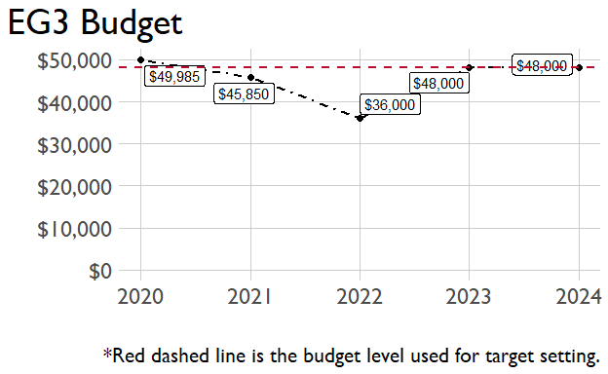

## Active Portfolio

The following activities are considered “active” based on their reporting in FY 2023 and expected FY 2024 reporting. The Analytics, Data and Learning Division defines an “active” activity as one that reported non-NA values for targets, actuals, or deviation narratives for the current year (FY 2023), or the next out-year targets.

## High-reporting Activities

The following activities are in the top three for at least one indicator.

|  |  |  |  |  |
| --- | --- | --- | --- | --- |
| Activity Name | Activity End Date | Managing Office | Relevant Indicator Codes | TEC amount |
| AUHC - Advancing Universal Health Coverage Activity | 12/31/2023 | Population, Health, Nutrition and Education | HL.9-3; HL.9-1 | $83,704,694 |
| 107861: FTF Bangladesh Agricultural Policy Activity (Policy LINK) | 9/2/2025 | None | EG.3.1-d | $77,500,000 |
| MaMoni MNCSP -Mamoni Maternal and Newborn Care Strengthening activity | 4/25/2023 | Population, Health, Nutrition and Education | HL.9-4; HL.9-3 | $71,270,031 |
| FTF Bangladesh Nutrition Activity | 9/30/2028 | Economic Growth | HL.8.2-2; HL.8.2-5; EG.3-2; EG.3.3-10 | $58,068,727 |
| MISHD - Marketing Innovations for Sustainable Health Development | 10/16/2022 | Population, Health, Nutrition and Education | HL.9-1; HL.9-4 | $29,000,000 |
| FTF Bangladesh Aquaculture Activity | 2/5/2023 | Economic Growth | EG.3.2-26; EG.3-2; EG.3.2-27; GNDR-2; EG.3.2-24; YOUTH-3; EG.3.2-25 | $28,458,192 |
| Feed the Future Bangladesh Livestock and Nutrition Activity | 9/14/2026 | Economic Growth | EG.3.2-27; EG.3-2; EG.3.2-24; GNDR-2; EG.3.2-26 | $20,500,000 |
|  |  |  |  |  |
|  |  |  |  |  |
|  |  |  |  |  |
|  |  |  |  |  |
|  |  |  |  |  |
|  |  |  |  |  |
|  |  |  |  |  |

### 

### Appendix 1: Key Issue Narrative Section 4 Excerpts

The USAID USAID Bangladesh (BANGLADESH) Key Issue Narrative includes the following explanations for their performance against IM-level FY 2024 targets, which were set prior to the establishment of the Performance Targets. For **Not on Track** targets, Operating Units should review the narratives below and add to the explanation as applicable to explain

## Performance Target 1: Sales

Narrative is not needed for 'On track' Performance Targets.

## Performance Target 2: Gender financing ratio

Narrative is not needed for 'On track' Performance Targets.

## Performance Target 3: Hectares under climate adaptation and risk mitigation management practices

A total of seven projects reported FY 2023 results for this indicator, with the overall result being 47 percent higher than the target. This is primarily because of the overachievement by the Aquaculture project, the Horticulture project, and the Livestock project. The Aquaculture project, which was scheduled to end this year in February, received a time extension through November. As a result, the project was able to reach more aquaculture beneficiaries than targeted. The Horticulture project formed additional partnerships with input firms, which contributed to covering more crop lands. In addition, the Livestock project was able to cover more lands for fodder cultivation thanks to additional outreach and training for the farmers, leading to a higher area coverage. Future outyear targets will decline due to the Aquaculture project ending in 2023. The rest of the projects as well as the new CSA project have set FY 2024 and FY 2025 targets based on their annual work plans and FY 2023 implementation experience. USAID will revisit the FY 2025 targets during the FY 2024 PPR and adjust as needed based on FY 2024 results, implementation experience, and start-up time of the new activities.

## Performance Target 4: Private sector investment

## Narrative is not needed for 'On track' Performance Targets.

## Performance Target 5: Minimum dietary diversity for women (in the ZOI)

Narrative is not needed for 'On track' Performance Targets.